**Edit your society page online**

**[](https://www.wolvesunion.org/)**

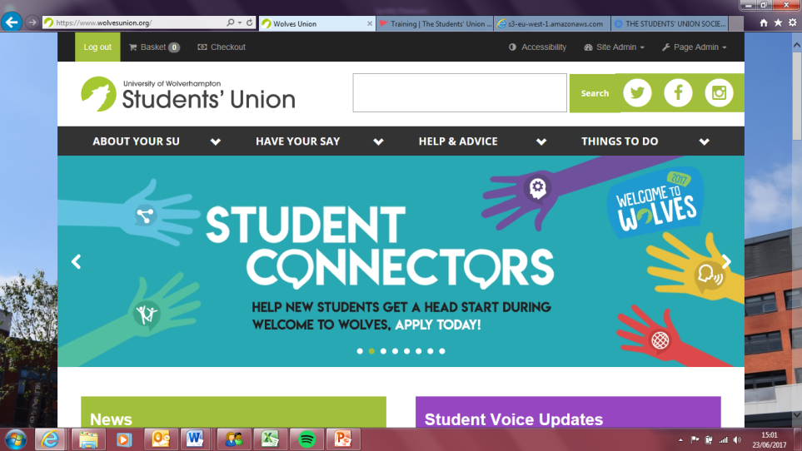

Sign into the Students’ Union website using your University credentials.

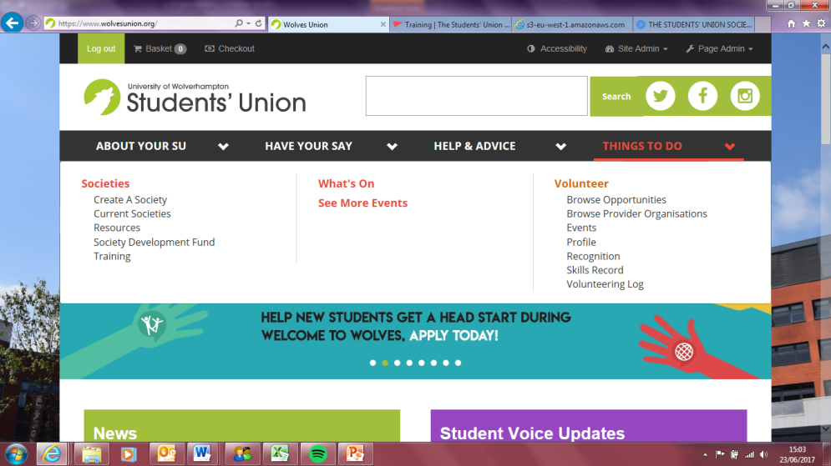

Click on ‘things to do’

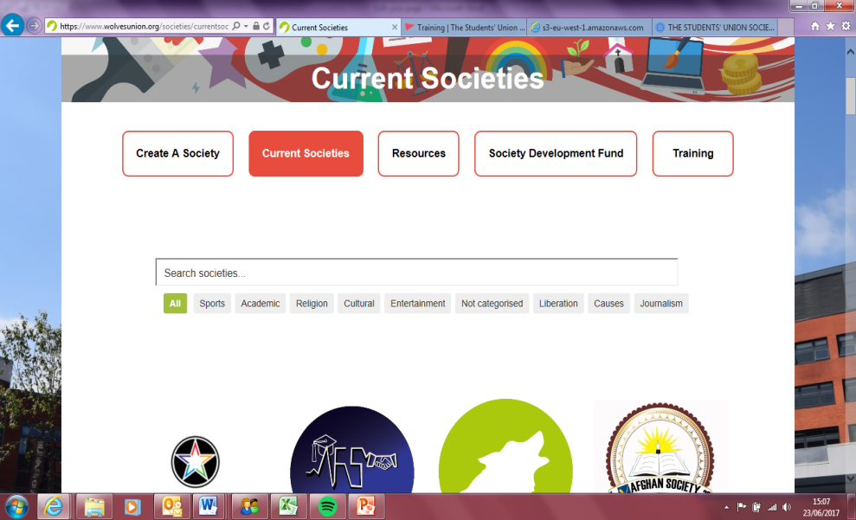

Click on ‘Current societies’

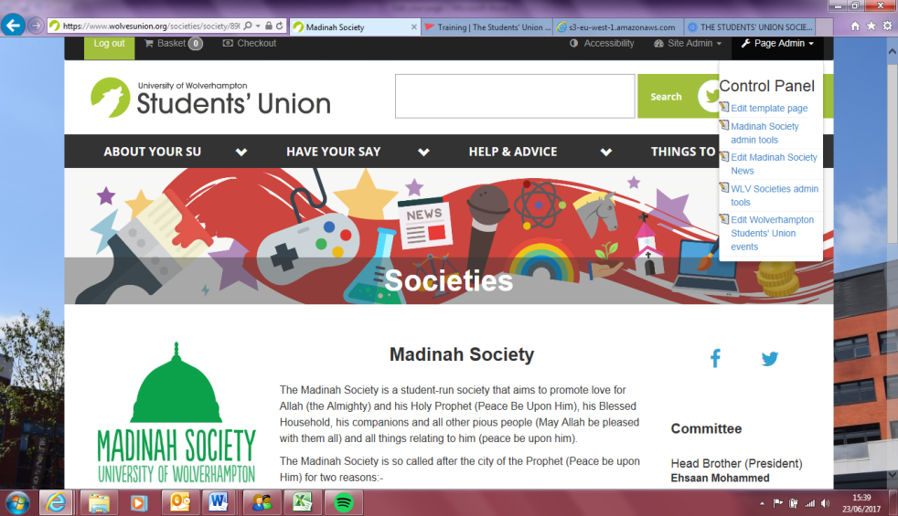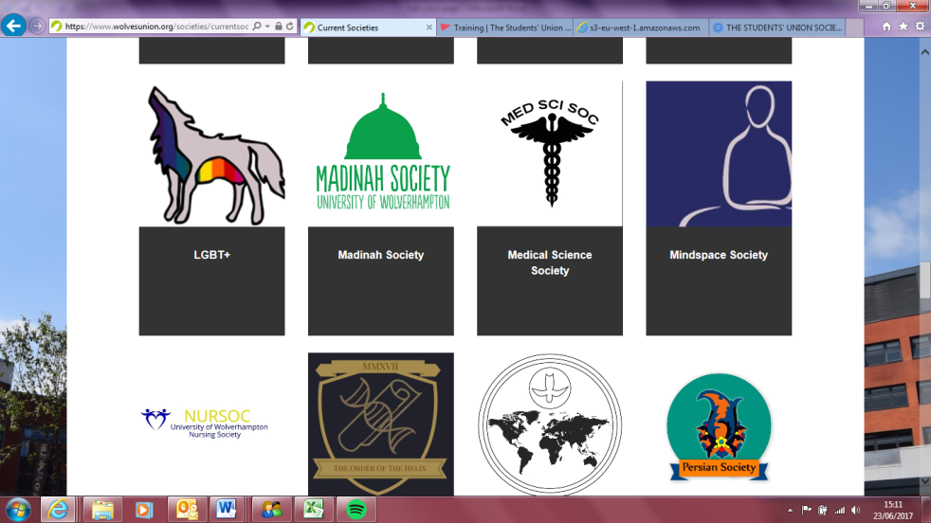

Once you have clicked on your society’s name, please click on ‘Page Admin’, and then click on, ‘(your society’s name) society admin tools’.

Click on your society page. (Scroll down to view all)

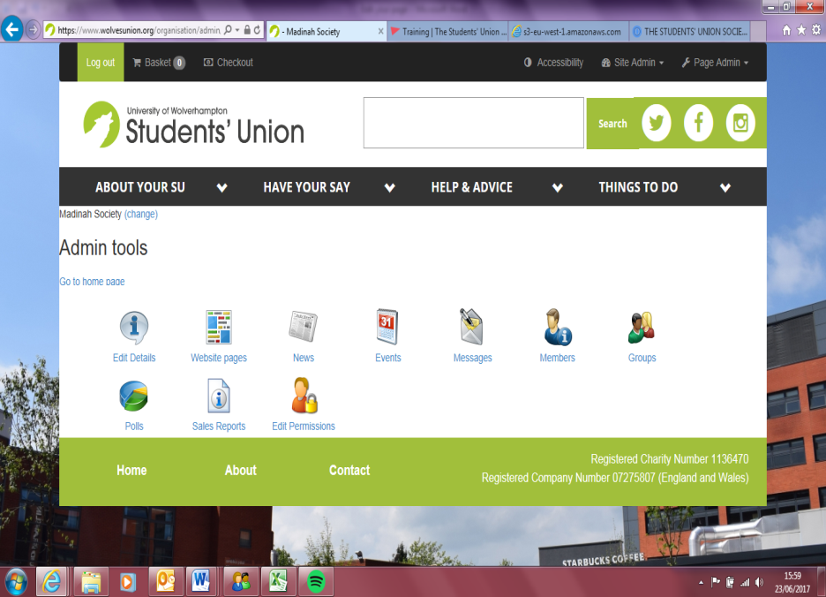

To put your society event on the ‘what’s on’ page please click on ‘Events’.

To edit the content that shows up on your page please click on ‘Edit details’.

View your current members

To add more than 1 event, please click where it says ‘Add new event’.

To contact the members of your society, click on ‘Messages’. You will be able to send a message to all members using this.